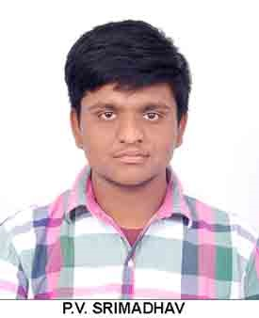
RESUME0

PV SRIMADHAV

Cell: +917981724397

Cell: +919100259652
Email: srimadhav@outlook.com
----------------------------------------------------------------------------------------------------------------
Career Objective:
To work for an organization which provides me the opportunity to improve my skills and knowledge to growth along with the organization objective.

Educational Qualification:
- COMPLETED Intermediate HEP from Telangana Open Intermediate Educational Board.
- S.S.C from Board of Secondary Education, Triveni High School.
- COMPLETED DIPLOMA IN AVIATION COURSE IN STAR FLYERS AVIATION ACADEMY.
- Photoshop course in reliance academy

Computer Skills:
Basic knowledge in Excel, Word and Power Point Presentation,photoshop
Strengths:
- Good Communication Skills.
- Ready to take any responsibility.
Extra Curricular Activities:-
- Playing Cricket
- Reading News Paper
- Watching Historical And Patriotic Movies .
- Reading adventure book like (SHOOT,DIVE&FLY)
Personal Profile:
Name : PV SRIMADHAV
Father Name : PV SRIHARI
Date of Birth : 25-05-1999
Marital Status : Un Married
Religion : Hindu
Nationality : Indian
Languages Known : English, Hindi and Telugu
Address : FLAT NO-101, ABOVE
BANK OF BARODA
TARNAKA ,HYDERABAD
TELANGANA,SECUNDERABAD, 500017
PASSPORT NO :- T6134654
AADHAR CARD NUMBER :- 542361483764

Declaration:
I here by declare that the above information is correct and true to the best of my knowledge.

Place: SECUNDERABAD,TARNAKA
Date :
(PV SRIMADHAV)

